Virginia:
median_income | thirty_year_commitment_rate | mortgage_originations | unemployment_rate | population_size | foreclosures | building_permits
0 | 0 | 22 | 0 | -2#3 | 0,10 | 0

Final model:

Call: rlm(x = shifted.multivar.test.data.vector[, 1:(n - 1)], y = shifted.multivar.test.data.vector[,
n])
Residuals:
Min 1Q Median 3Q Max
-8.415e-03 -1.797e-03 5.881e-05 1.872e-03 9.614e-03

Coefficients:
Value Std. Error t value
population_size-Lag-2 4.4955 0.7980 5.6331
median_income-Lag0 0.3320 0.0954 3.4804
foreclosures-Lag0 -0.0041 0.0011 -3.5999
mortgage_originations-Lag22 0.0009 0.0005 1.9665
population_size-Lag3 5.3908 0.7748 6.9574
foreclosures-Lag1 -0.0054 0.0012 -4.5528
foreclosures-Lag2 -0.0034 0.0007 -4.6511
foreclosures-Lag3 -0.0032 0.0008 -3.7856
foreclosures-Lag4 -0.0030 0.0008 -3.8504
foreclosures-Lag5 -0.0021 0.0008 -2.7005
foreclosures-Lag6 -0.0029 0.0008 -3.6227
foreclosures-Lag7 -0.0020 0.0007 -2.6851
foreclosures-Lag8 -0.0019 0.0007 -2.6940
foreclosures-Lag9 -0.0018 0.0006 -2.7319
foreclosures-Lag10 -0.0022 0.0006 -3.6175

Residual standard error: 0.002776 on 86 degrees of freedom

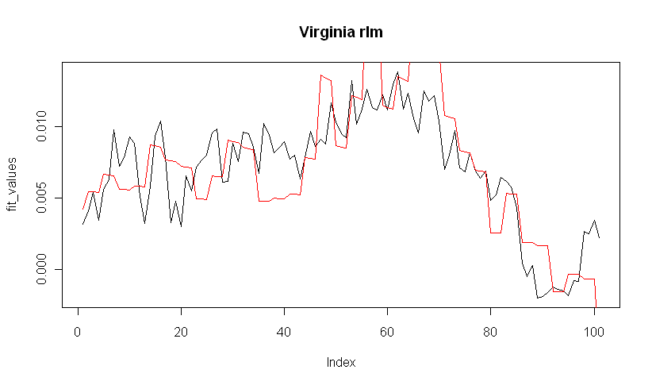

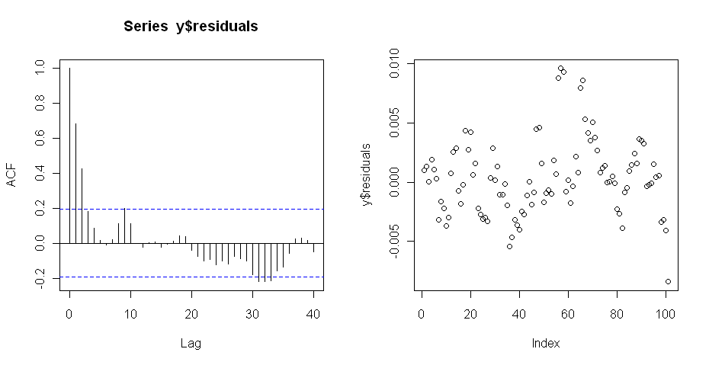
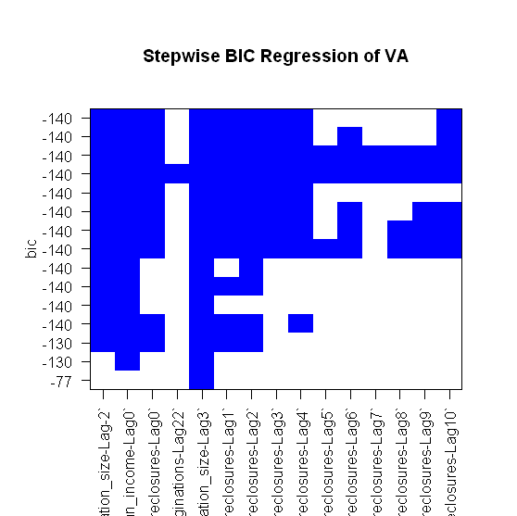

BIC = -140

Box-Ljung test

data: y$residuals
X-squared = 79.4756, df = 12, p-value = 5.196e-12

Augmented Dickey-Fuller Test

data: y$residuals
Dickey-Fuller = -2.9717, Lag order = 4, p-value = 0.1739
alternative hypothesis: stationary

